**Assignment 🡪 3**

AIM:

Q.1 Take input from the user and if the student's marks is >=75, then print distinction

if marks<75>=60, then print average marks

if marks <60>=40 then print below avg.

if marks<40, then print fail

Q.2 Take input from the user and return the total bus ticket fare:

if age>=60, then give 50% discount

if age<60>18, then no discount on ticket

if age<18, then 80% discount

you have to take input from the user such that it will take input as age and according to age it will print.

CODE :

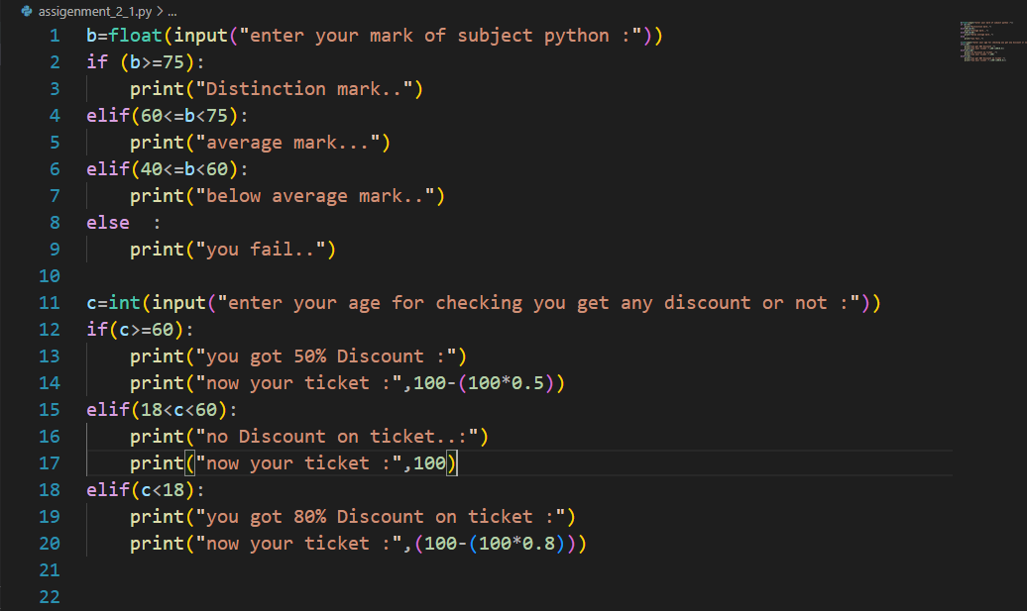

OUTPUT:

